Tree: displays files and directories in tree structure.

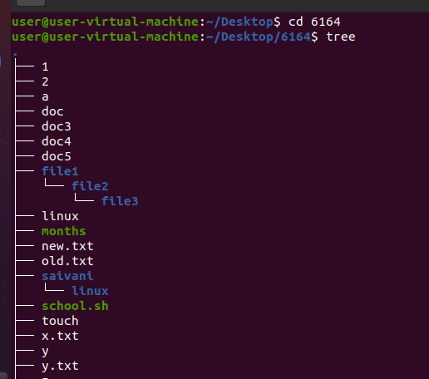

Grep ‘ ‘:displays specific charecters

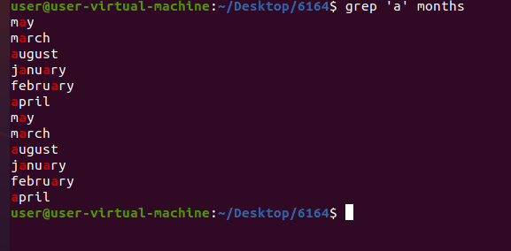

More frame :displays data over the terminal.

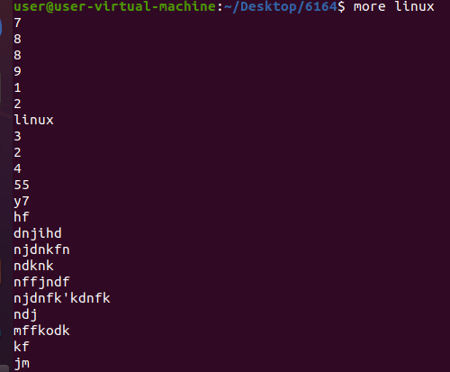

Grep-I : displays non case sensitive charecters.

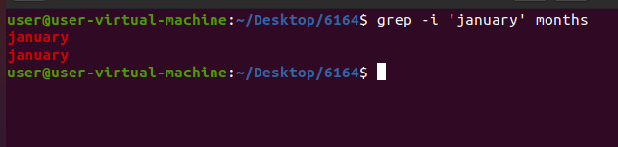

Grep-I ‘ ‘ file1 and file2 : display multiple files.

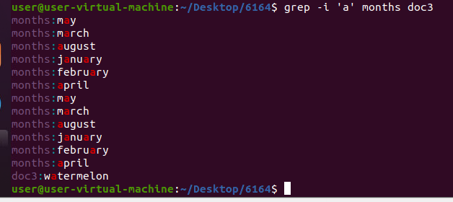

Grep-I ‘ ‘ \*: displays all specific characters in all files.

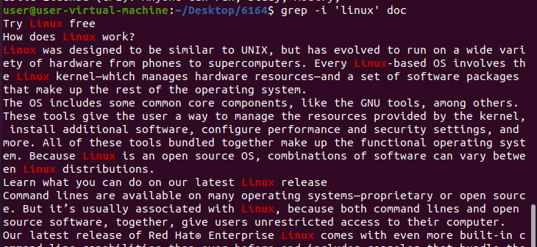

Grep -I -c ‘ ‘ fname – gives count of character in lines.

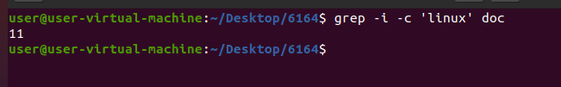

Grep -I –c ‘ ‘ \*- in all files.

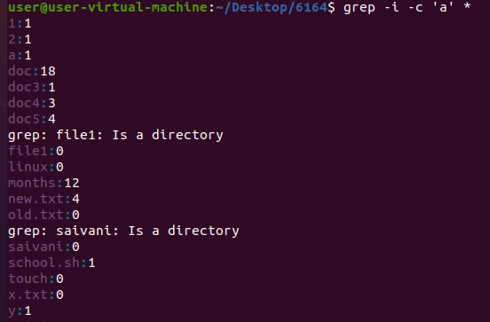

Grep -I –l filename: lists file with word present.

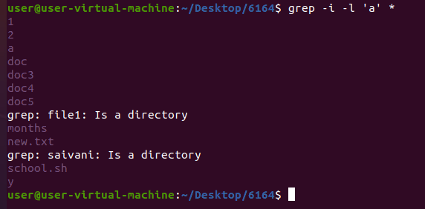

Grep -I –o ‘ ‘ filename :gives output of words in lines only

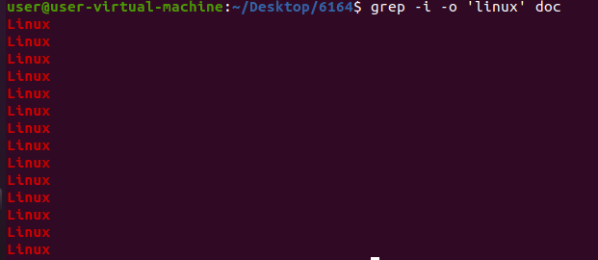

Grep -I –n ‘ ‘ filename : display number of lines.

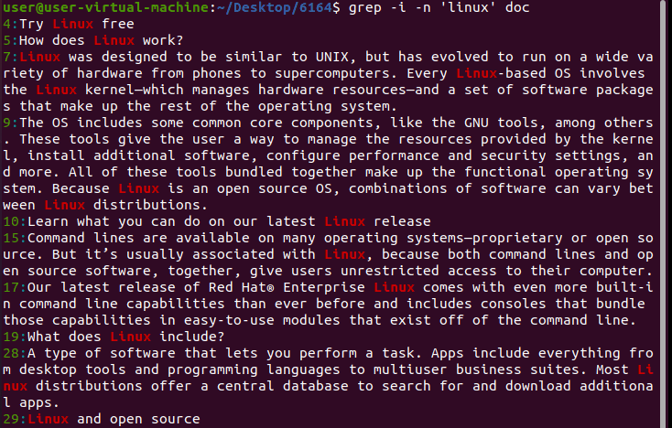

Grep -I –v ‘ ‘ filename :gives lines without specified word.

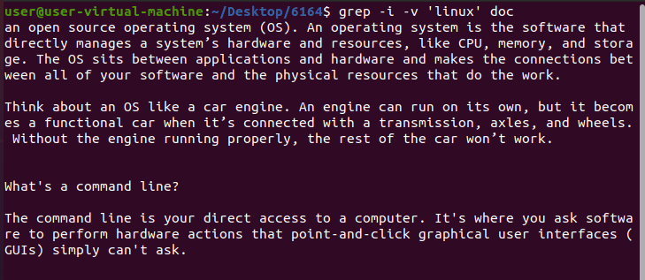

Grep ‘^’ filename: gives lines starting with specified word.

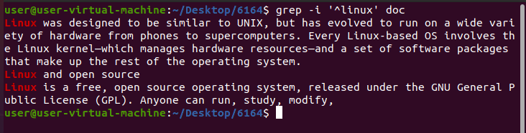

Grep -I ‘$’ - gives lines ending with specified word.

Grep -I –an ‘ ‘ filename-prints after lines after specified word found.

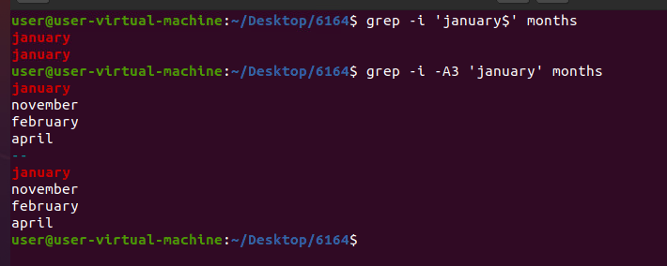

Grep -I –bn ‘ ‘ fname :prints before lines after specified word found.

Grep -I cn ‘ ‘ fname :prints before and after lines specified word found

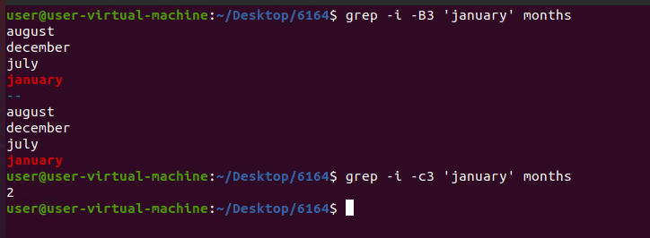

Cat filename [tr ‘[a-z]’ ‘[A-Z]’: converts all the data into upper case

Cat